# C:\Users\Emrah\Desktop\MUMF-Logo.jpgMARMARA UNIVERSITY

## FA C UL T Y O F E NG INE E R I NG

**ME3071 – HEAT TRANSFER TERM PROJECT**

**A MALT DRINK FACTORY DESIGN**

Name : Ufuk MAMİKOĞLU

Number:150415055

**HEAT TRANSFER PROJECT REPORT**

Department of Mechanical Engineering

**Supervisor**

Dr. Mehmet Rafet Özdemir 01.07.2020

1. **INTRODUCTION**

In this paper, we are going to apply our learnings in Heat Transfer course to the design of a malt drink factory. In a malt drink factory, the brewery process begins by immersing the barley grains into the water to germinate and produce enzymes. This process is called ‘malting’. As a result of this process, complex sugars are transformed into simple sugars. However, the germination process should end before all sugar is consumed. We can end this process by drying the seeds in an oven. After this process, the grains are dried and they are soaked into the hot water in an insulated barrel and stirred thoroughly to stop clumping. This process is called ‘mashing’ and the barrel is called the mash tun. The temperature should be maintained and adjusted if too low. The hot sparge water is then added to the mash tun. The worth created in this process is taken out of the mash tun and put into the brew kettle and boiled. Therefore, the boiled wort is become sterilized. This sterilized wort must be cooled rapidly before the fermentation. As a final step, the product is packaged in containers and the brewing process is completed.

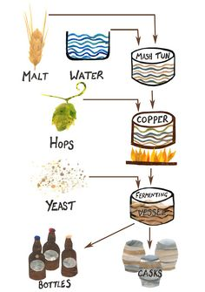

Figure 1.1: Simple Brewing Process

We can see a simple overview of the process in the schematic below:

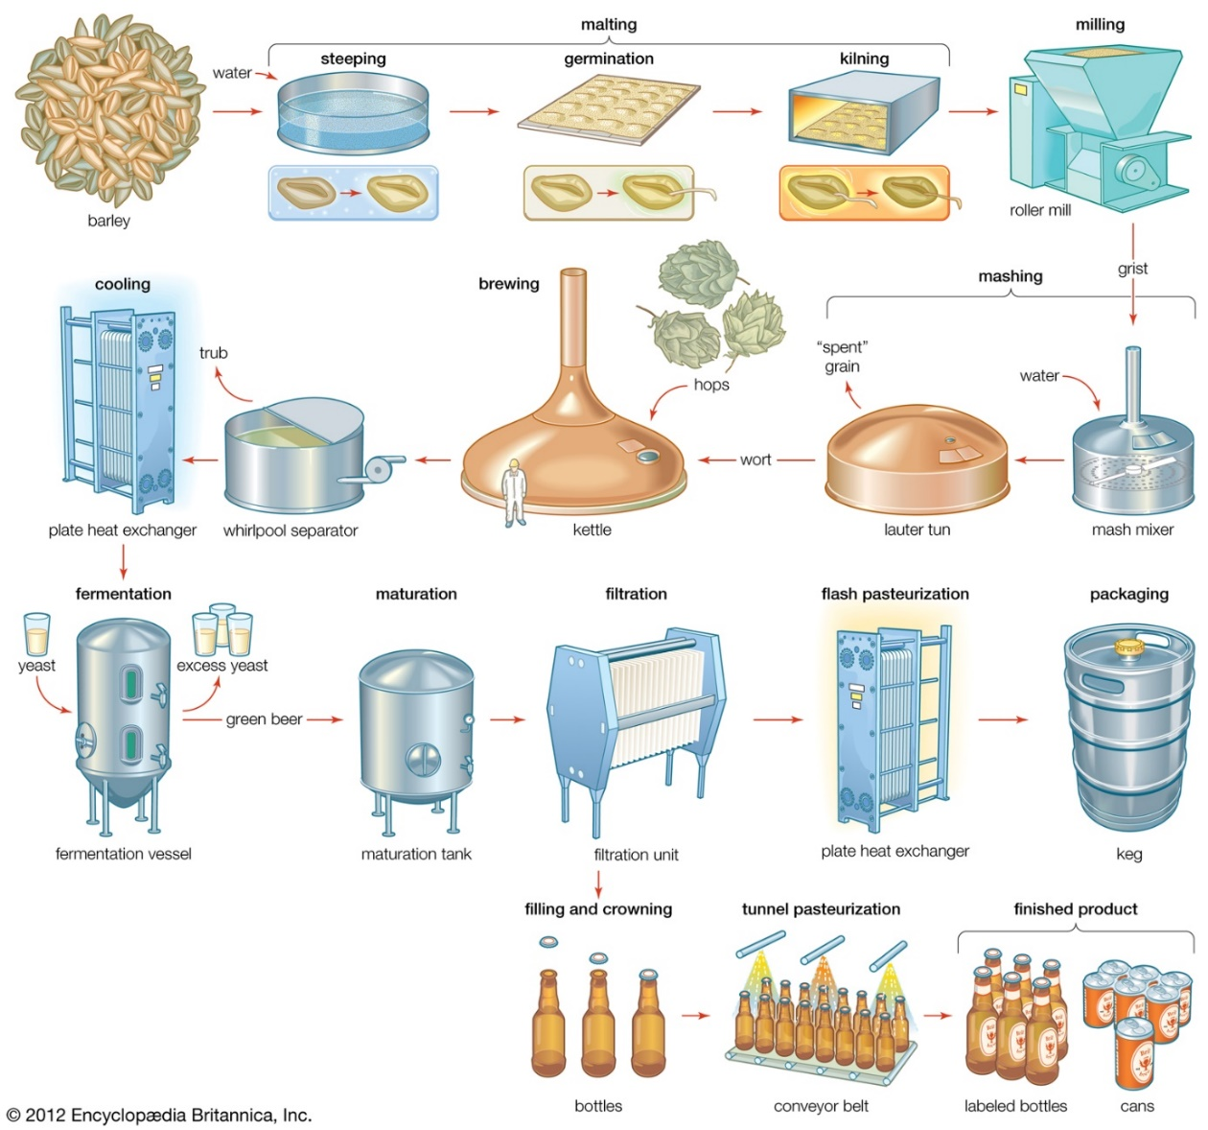

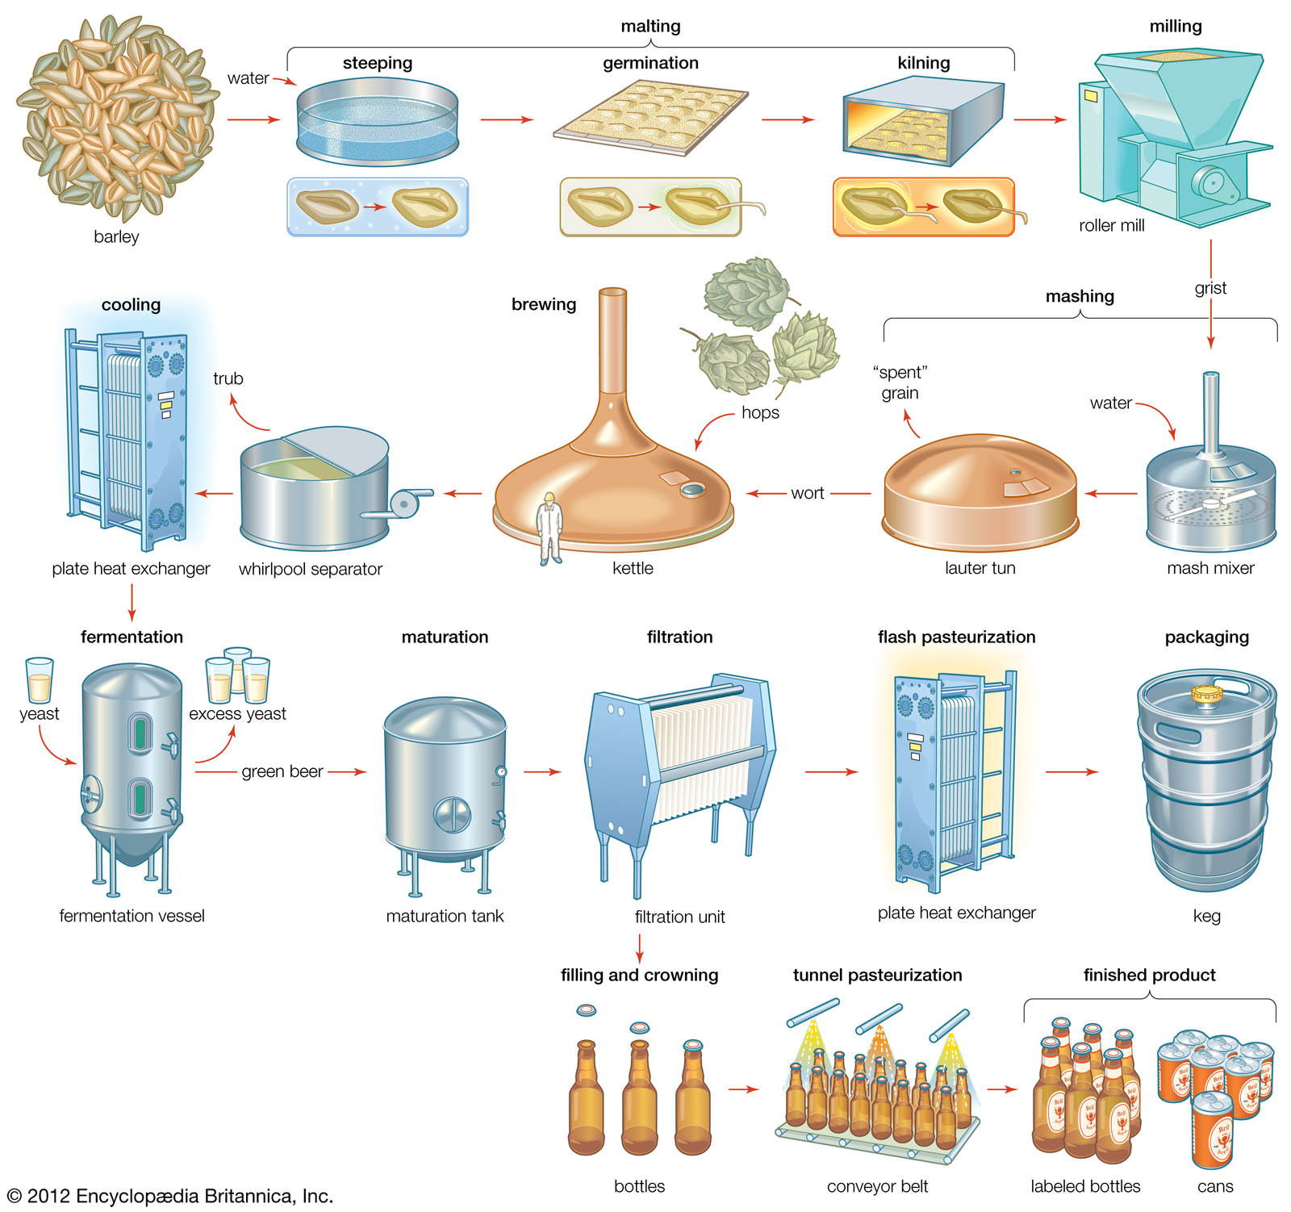

Barley Grains Malting Drying The Seeds

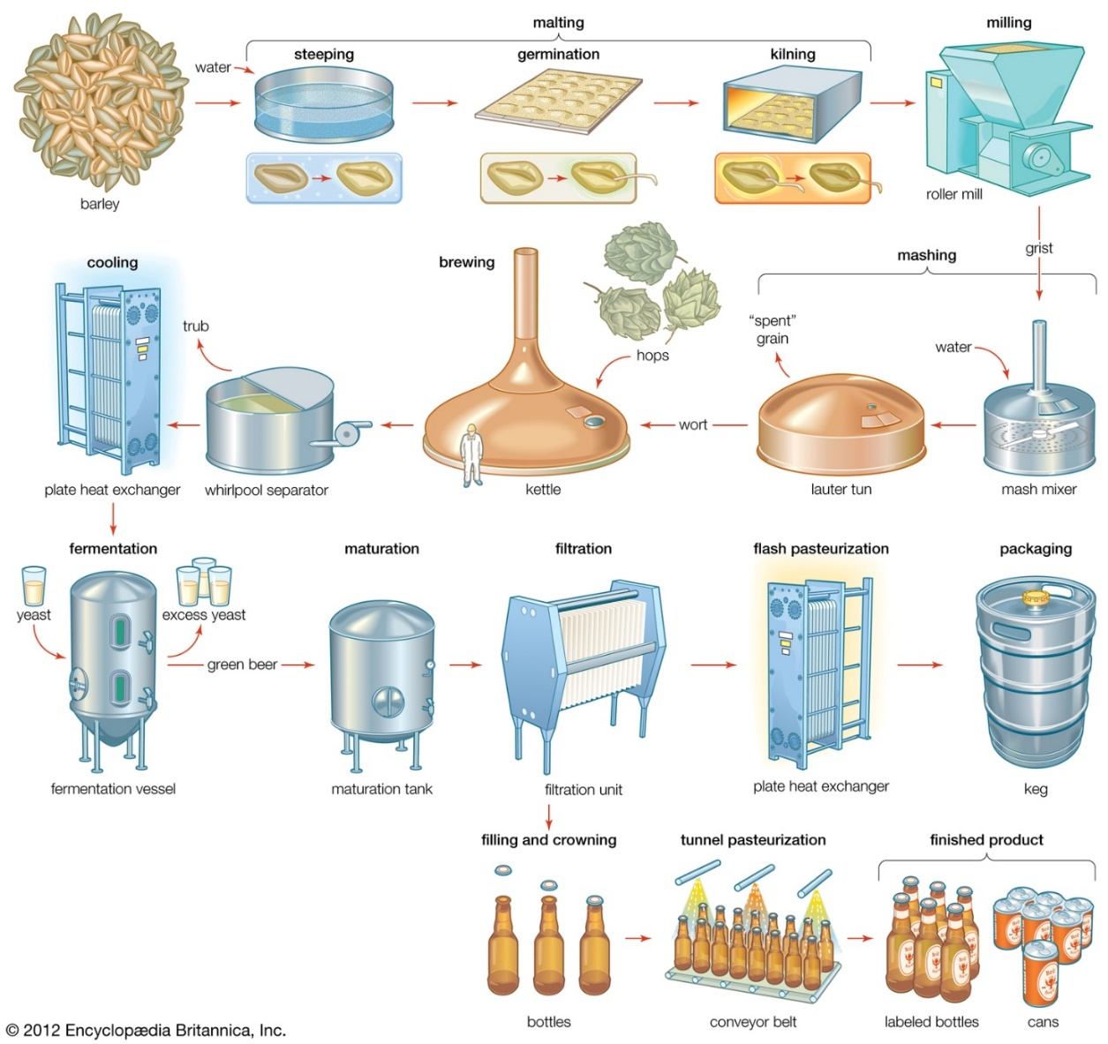

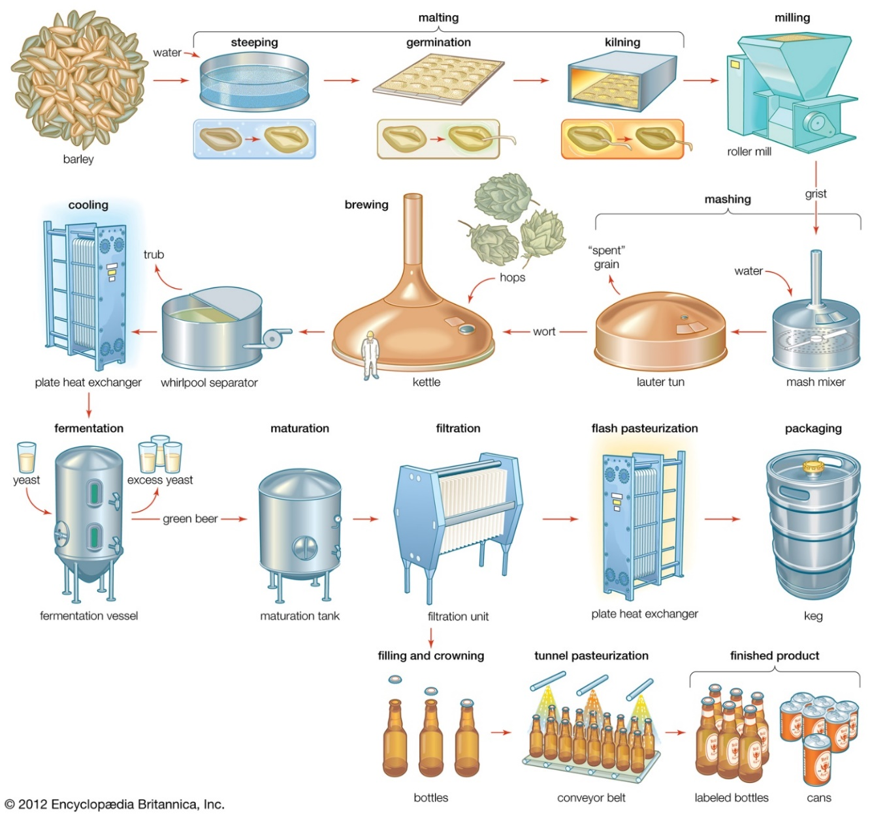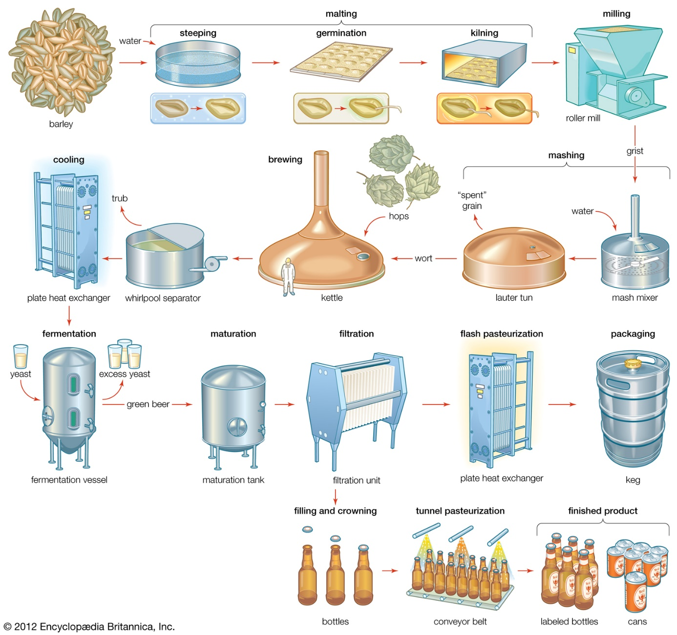

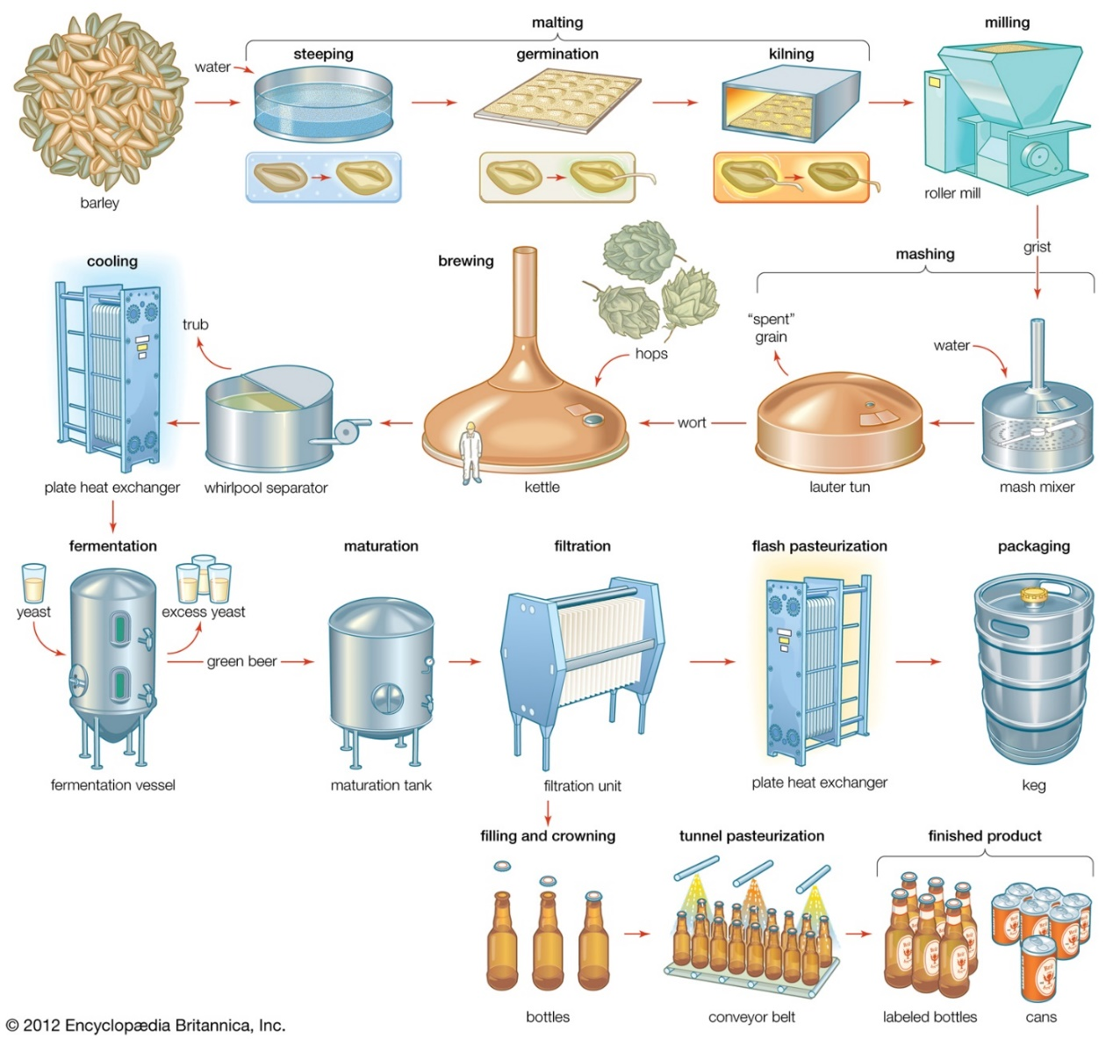

Mashing Heat Exchanger Fermentation Packaged Products

Figure 1.2: Overview of Brewing Process

1. **PROBLEM STATEMENT**

We have mentioned the process of brewing in the section above. In this section, we will be stating the tasks that we need to complete for brewing. We will be simplifying and adjusting this process for us so that we will be able to implement our knowledge on heat transfer.

The brewing process can be divided into 5 main tasks:

1. **2-SIDES HEATED OVEN DESIGN**

At the end of the germination process, we need to supply heat the grains to prevent the consumption of all sugar. To do that, we can design an oven which is heated from two sides. In the oven, there is radiation and natural convention heat transfer.

1. **TANKLESS/IN-LINE WATER HEATER DESIGN**

We need to supply hot water to the insulated barrel for mashing process. Normally, the hot water is added separately for a couple of times. However for the simplicity, we will assume that we add the hot water once and it is going to be provided from an in-line water heater. The hot water should be around 50-65°C.

1. **INSULATED BARREL DESIGN**

The grains and the hot water mix need to stay 1-2 hours in the tank and the temperature should stay hot enough for the whole time. Therefore, we need to provide insulation for the barrel.

1. **PLATE AND FRAME HEAT EXCHANGER DESIGN**

After keeping the grain and water mix in the mash tun for 1-2 hours, the obtained liquid is sterilized by boiling it 2 hours. The sterilized production then must be cooled rapidly to the 20°C using a plate and frame heat exchanger.

1. **CONTAINER DESIGN**

As a final step, the product is packaged in one of several types of containers with different dimensions and thermal conductivities. We need to make sure that the temperature of the drink stays fairly constant during the time of consumption. Also we need to consider the other affects like being environmentally friendly etc.

1. **PROBLEM SOLUTION AND CALCULATIONS**

In this section, we will be presenting our calculations for the given tasks. To determine how much product we want to produce and how much kilograms of grain, water that are needed to use to obtain this product, we use a water amount calculator that can be easily found on the internet.

Table 3.1: Water/Grain Amounts Table

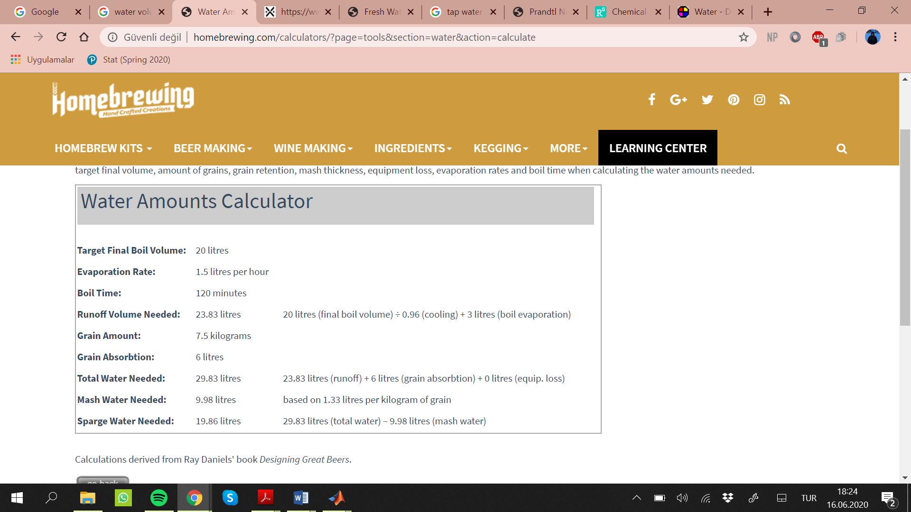

In our design, we decide to use 7.5 kilograms of grain to obtain 20 L of product at the end.

1. **2-SIDES HEATED OVEN DESIGN**

Ovens are used for heating substances, drying or cooking foods and they are heat insulated. In this scope of our project, we will use oven for the drying purpose. Drying ovens are generally designed to remove moisture.

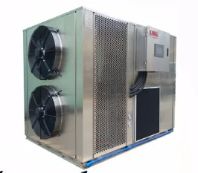

Figure 3.1: Grain Drying Machine

In the figure 3.1 and 3.2 commercial drying machines are shown. We designed an oven based on this drying principles.

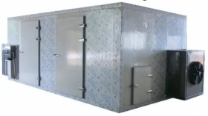

Figure 3.2: Corn Dryer

We designed our oven to stay as close to real values ​​as possible. We found out that the most logical commercial oven should be 100x100x200 cm3 according to the amount of grain we have.

We assumed that we had 7.5 kg of grain. The operating temperatures of the drying ovens can vary according to the working place and conditions. Since we aim to adhere to real life examples, we have taken the ambient temperature 30°C and the surface temperature of the oven as 180°C. As a result of our research, we have reached the information that barley is dried in 50-70°C. The operating temperatures of the ovens we found in this regard were between 50 and 300°C. For this reason, we took the surface temperature as 180°C.

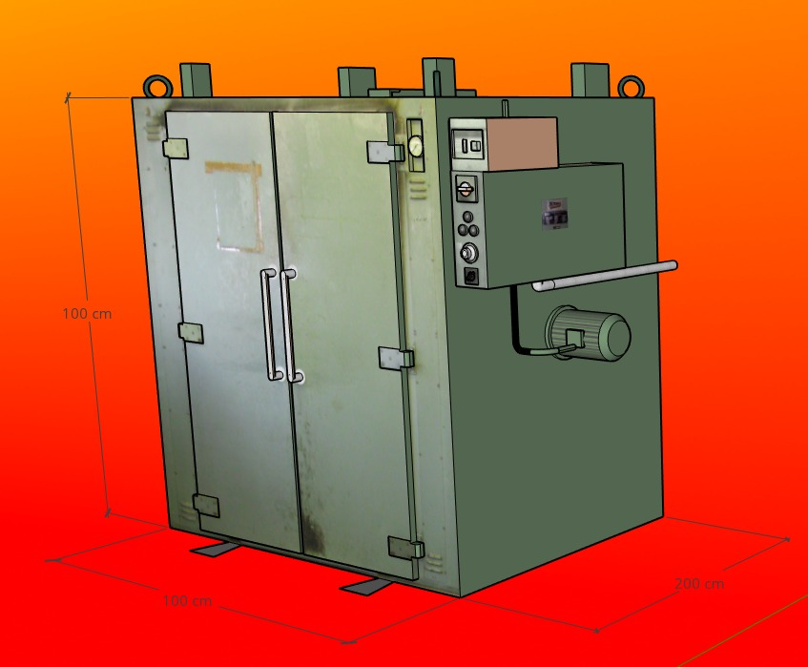

Figure 3.3 Our Oven Design

**Analysis and Calculations**

Analysis operations are started by finding the film temperature. Since we take the surface temperature 180°C and the ambient temperature 30°C, the film temperature is found from the equation below.

Tf  = =

From the Table A-15 in our textbook, properties of air at 1 atm pressure and ${110}^{o} C$

d = 0.9218 kg/m3

k = 0.03165 W/m.K

υ = 2.414 x 10-5 m2/s

Pr = 0.7092

ß = $\frac{1}{T_{f}}=\frac{1}{383 K}=2.61 x {10}^{-3}$

The characteristic length is Lc = 100cm = 1 meter. Then Rayleigh number is:

$Ra= \frac{g ß \left(T_{s}-T_{∞}\right) L^{3}}{υ^{2}} Pr = \frac{9.81*0.00261* \left(180-30\right)1^{3}}{2.414* {10}^{-5}}*0.7092=112,832$

= 1.13 x 105

which is equal to 1.13 x 105 . After Rayleigh number is found, Nusselt Number will be found. To find more accurate results, equation 9-21 from the textbook was used.

Nu = ${\left\{0.0825+ \frac{0.387 {Ra}^{1/6} }{{\left[1+{\left(\frac{0.492}{Pr}\right)}^{9/16}\right]}^{8/27}}\right\}}^{2}= {\left\{0.0825+ \frac{0.387*{(1.13* {10}^{5}) }^{1/6} }{{\left[1+{\left(\frac{0.492}{0.7092}\right)}^{9/16}\right]}^{8/27}}\right\}}^{ 2}=5.47$

$$h= \frac{k}{L_{c}} Nu= \frac{0.03165 }{1 } 5.47=0.173 \frac{W}{m^{2 }. C}$$

$$A_{s }= 2*1*1=2 m^{2}$$

$$\dot{Q}=h A_{s} \left( T_{s}-T_{∞} \right)+ε A_{s} σ\left( {T_{s}}^{4}-{T_{surr}}^{4} \right)$$

$$=0.173* 2*\left( 180-30 \right)+0.3*2*5.67*{10}^{-8}\left( ({180+273)}^{4}-{(30+273)}^{4} \right)$$

$$1,198 W$$

We obtained that the total heat loss by combined natural convection and radiation is 1,198 W. We choose 100x100 cm2 surface area instead of 100x200 cm2 because as the surface area increases, heat loss increases. We assumed that barley grains rest on the bottom surface of the oven. Barley grains are 7.5 kg and initial temperature is 25°C. Then, we calculate the heat transfer rate between the heating element and the grains to calculate how much time we need to dry them. Ideally drying is occur at 60°C and then from the equations below we can calculate the drying time. Here A1 is 1 m2 and A2 is 2 m2 F1-2 is view factor between surface1 to 2. View factor can be found from the Figure xx with intersecting the necessary values.

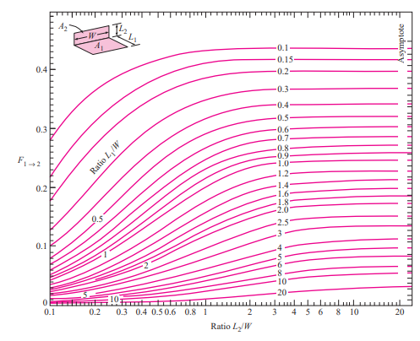

Figure 3.4: View factor between two perpendicular rectangles with a common edge.

From the Figure 3.4, we intersect the values and we found F1-2 = 0.29 which is a dimensionless quantity. We assumed the inside is commercial steel and it has 0.3 emissivity value. For consider the barley grains like wood, that is why we assumed that it’s emissitivy is 0.9.

$$ξ_{1-2}=\frac{1}{\frac{1-ε_{1} }{A_{1}ε_{1}}+\frac{1}{A_{1}F_{1-2}}+\frac{1-ε_{2}}{A_{2}ε_{2}}} = \frac{1}{\frac{1-0.3 }{1*0.3}+\frac{1}{1*0.29}+\frac{1-0.9}{2*0.9}}=0.17$$

$${\dot{Q}}_{rad,1-2}=σξ_{1-2}\left(T_{1}^{4}-T_{2}^{4}\right)= 5.67*{10}^{-8} *0.17*\left( {453}^{4}-{298}^{4}\right)=330 W$$

We have 2 heating elements, that is why the total heat transfer rate for radiation is 2*330 W = 660 W. To see the performance of our oven, we calculate the drying time of oven. For that purpose we used the following equations to find how much heat needed for this process. In this equation $m_{barley grain}$ is the mass of barley grain with the unit of kilogram and $C_{P,barley grain}$ is the specific heat at constant pressure in J/kg.K and $ΔT$ is the temperature difference in Kelvin.

$$Q_{barley grain}=m_{barley grain}*C_{P,barley grain}*ΔT$$

$$Q_{barley grain}={\dot{Q}}_{rad,1-2}*t$$

$$m_{barley grain}*C_{P,barley grain}*ΔT= {\dot{Q}}_{rad,1-2}*t$$

$$7.5 *1631.6 *\left(\left(60+273\right)-\left(25+273\right)\right)=330*t$$

$$t=1,298 second=21.63 minute$$

With the oven design we made, we calculated that we can dry 7.5kg of barley grain in about 22 minutes. To dry the barley grains quicker and with less energy, it is necessary to minimize heat loss. The main method used to reduce heat loss is to use insulation material. Glass wool is one of the most used insulation materials because it is inexpensive and easy to find. Another alternative is rock wool. They are suitable for basic projects because both of them are produced in our country and can be easily accessed. Isolation materials can be used for further studies.

Glass wool, is made from a mixture of natural and recycled glass (recycled bottles, car windscreens and window panes) which is melted at 1,450 °C, and is then spun quickly to create fibres. These fibres are then bound together to be used as insulation. The glass fibres create pockets of air which act as barriers to prevent heat loss, because air is a poor conductor of heat. Glass wool can be found in batts and rolls and also within insulation boards.

Rock wool is made from volcanic rock (dolomite, diabase and basalt), which is not a recycled material, but is an abundant resource. Slag wool is made from the recycled waste product of a blast furnace. Stonewool gives a higher quality and performing product than Slag wool, even though the two are often referred to as Rockwool. These raw materials are treated in a similar way to glass, they are melted at high temperatures (about 1,500°C), and then they are spun to form fibres. This wool is then packaged up into batts, rolls or slabs.

Both have similar features. From its main differences, rock wool can operate at higher temperatures but it is more expensive than the rock wool.

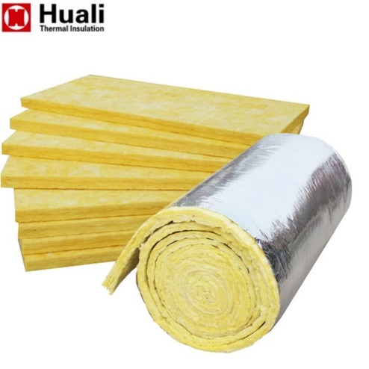 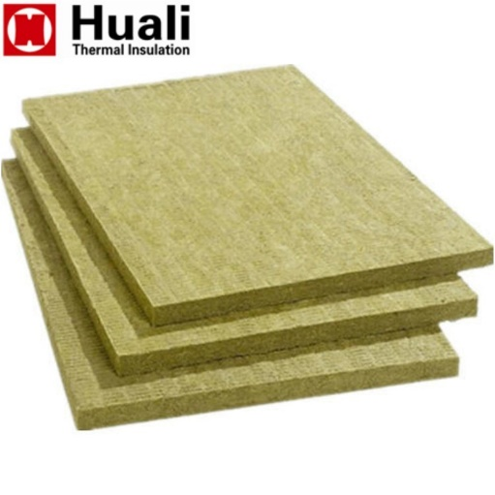

Figure 3.5: Glass Wool and Rock Wool

1. **TANKLESS/IN-LINE WATER HEATER DESIGN**

The hot water needed for the barrel is going to be provided by the in-line water heater. We decided to provide ‘fresh water’ for our in-line water heater which is at approximately 20°C. The properties of the fresh water at 20°C is given in the table below.

Table 3.2: Fresh Water Properties

|  |  |
| --- | --- |
| Fresh Water Properties at 20°C |  |
| Density | 998.2072 kg/m3 |
| Viscosity (µ) | 0.001002 Pa.s |
| Specific Heat (Cp) | 4.1818 * 103 J/kg.K |
| Thermal Conductivity (k) | 598.4*10-3 W/m.K |

An in-line water heater can be shown as a simple circular tube. There are some variables that specify its design process: inlet, outlet and surface temperatures, diameter, length and mass flow rate. We can see an example schematic below for the representation of these variables.

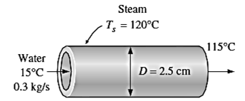

Figure 3.6

In our design, we need to determine a suitable diameter and length for the heater; and the temperature values. We are given as a design criteria that the output temperature should be 65°C. We have also specified the inlet temperature as 20°C because the average temperature of tap or fresh water is approximately at 20°C. We assume the surface temperature to be stay constant during the process. From our observations and research, we decided to take the surface temperature as 120°C.

The flow in circular tubes can be divided in 2 types depending on the flow characteristics: laminar or turbulent flow. To be able to design an in-line water heater, we need to firstly determine our flow’s characteristics such as Reynolds number, Prandlt number, Nusselt number.

$$Re=\frac{ρV_{m}D}{μ}=\frac{4\dot{m}}{μπD}$$

$$Pr=\frac{μC_{p}}{k}$$

$$Nu=1.86{\left(\frac{RePrD}{L}\right)}^{1/3}\left(\frac{μ_{b}}{μ_{s}}\right) laminar flow$$

$$Nu=\frac{\left(f/8\right)\left(Re-1000\right)Pr }{1+\left(12.7{\left(f/8\right)}^{0.5}\left({Pr}^{2/3}-1\right)\right)} turbulent flow$$

Where $f={\left(0.790lnRe-1.64\right)}^{-2}$

$$Nu=\frac{hD}{k}$$

For the constant surface temperature case;

$$\dot{m}C_{p}=-\frac{hA_{s}}{ln\left[\frac{T_{s}-T_{e}}{T_{s}-T_{e}}\right]}$$

The equations above are taken from the course textbook.

From the equations above we can see that flow characteristics depend on diameter and length. We also can see that different mass flow rate values give different Reynold numbers and therefore different Nusselt numbers. Therefore, we need to find optimal values for mass flow rate, length and diameter that works with the temperatures we chose. To do that, we did iterations on MATLAB with using the equations given above. We give the mass flow rate input as 0.5 kg/s and obtain the actual mass flow rate that we need in our water heater. In the code, we can also see the result of Reynolds and Nusselt numbers of the flow. The results can be read from the table below.

Table 3.3: Results

|  |  |
| --- | --- |
| $$T_{inlet}$$ | 20°C |
| $$T_{exit}$$ | 65°C |
| $$T_{surface}$$ | 120°C |
| $$D$$ | 0.25 m |
| $$L$$ | 2 m |
| *Pr* | 7 |
| $$\dot{m}$$ | 0.5461 kg/m |
| $$Re$$ | 3.1966 x 103 |
|  | 24.3412 |

1. **INSULATED BARREL DESIGN**

In the this part, insulated barrel is designed to keep the grains at 65°C for 1 hour. As the material of tank, stainless steel AISI 302 is chosen. This material is generally used in the industry. It has many advantages and it is a good decision for liquid, chemical and some other industries. Choosing steel prevents corision and other chemical reactions. As the insulation material, Polyurethane foam is selected. It is widely used in industry for insulation of tanks. Thickness of tank is selected as a 1,5 mm . It is the optimum tank thickness for this situation.

According to these choices made above, properties of materials of tanks and insulation is found and written in the table below.

Table 3.4 :Properties

|  |  |
| --- | --- |
| Properties of Materials | |
| stainless steel AISI 302  kmetal | 15.1 [W/m.K] |
| Polyurethane foam  kinsulation | 0.026 [W/m.K] |
| Thickness of metal | 1,5 mm [assumption] |
| Density of metal | 8055 [kg/m3] |

Secondly, dimensions of tank is going to be selected. Height of tank and radius of tank have high effect in terms of heat transfer rate. So, height and radius are selected minimum to minimize the heat tranfer rate.

To make a clear approach, selection H and r0 value is made from with optimization of surface areas.

Volume is calculated as 9500 cm3 for 7.5 kg grain

mgrain = 7.5 kg grain

dgrain = 0.79 g/cm3 = 0.00079 kg / (cm3)

d = m / v

v = m / d = 7.5 / 0.00079 = 9,493.67 cm3 ~ 9500 cm3

Total surface area is calculated with this formula.

Atotal=Aside+Abottom+Atop

Atotal =2*π*r1*H+π*r12+π*r12

V=π*r12*H

To reach optimum H and r0 values, MATLAB is used.

Table 3.5: Solutions

|  |  |
| --- | --- |
| Matlab solutions | |
| r0 | 11.4775 cm |
| H | 22.9550 cm |

By means of these values ,dimensions of tank are determined.

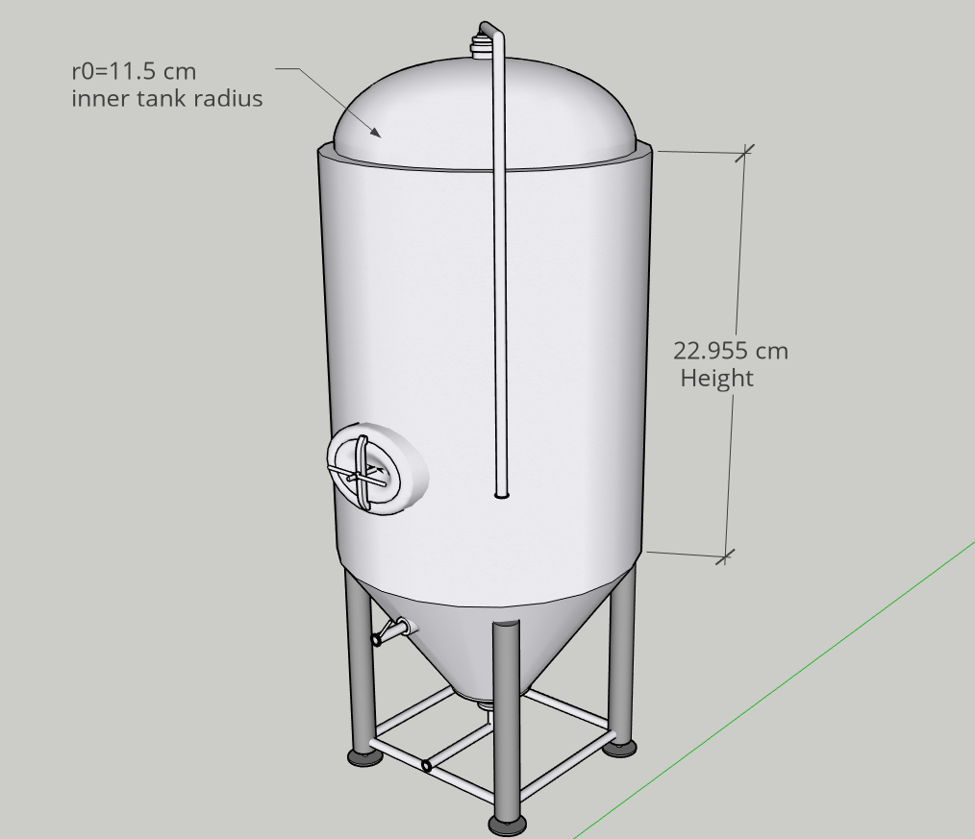

Figure 3.7 : Insulated Barrel

To reach to ideal insulation thickness, heat transfer rate must be known. There is said to be steady heat conduction and convection in this system. Therefore, it can be solved with thermal resistance concept. According to this concept, Rtotal can be found. For this tank, R must be calculated for every side of tank.

Rside=

Rtop=

Rbot=

To reach exact value of Rtotal,thickness of insulation must be found. Rtotal is necessary to reach heat transfer rate. Heat transfer rate can be formulated like given below:

Qdottotal=(Ttank-Tinf)/Rtotal = -ρ*V*CP*

The heat transfer rate is a good way to find the optimal thickness of insulation with iterations. For this purpose, MATLAB is used . From the iteration code, proper thickness of insulation is found as 0.12 cm.

Table 3.6: Thickness Value

|  |  |
| --- | --- |
| Matlab solution | |
| Thickness of insulation (tins) | 0.12 cm =1.2 mm |

1. **PLATE AND FRAME HEAT EXCHANGER DESIGN**

For our brewery factory, we are asked to design a plate and frame heat exchanger. A plate and frame exchanger transfers heat between two fluids with its thin metal plates that are stacked together one after another. The hot fluid comes in from an orifice travels through metal plates and comes out from the diagonal orifice. The same procedure applies to the cold liquid as well. Plate and frame heat exchanger’s main advantages is the much larger surface area. The larger the surface area is, the more the heat transfer is**.**

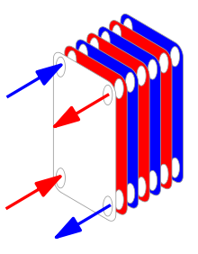

Figure 3.8:Heat Exchanger Model

From the figure above, we can see how the heat transfer occurs in the plates. Our goal here is to use water as coolant and cool down the product that was boiled before to 20°C. The boiled product is at 100°C and our coolant is water at 0°C. Therefore, we need to obtain a 80°C temperature drop. To be able to design a plate and frame heat exchanger for our goal, we need to decide the number of plates, plate’s size, metal’s and liquid’s properties. As the metal, we chose steel as it is preferred in many heat exchanger models. For obtaining the temperature drop of 80°C, we wrote a code and made iterations till we achieved our goal.

You can see the properties that we have chosen in the table below:

Table 3.7 :Properties of The Heat Exchanger

|  |  |
| --- | --- |
| Number of Plates | 100 |
| Plate Length x Width x Thickness | 8 m x 0.5 m x 0.002 m |
| Hot and Cold Water Gap | 0.008 m |
| Hot Water Temperature | 373.15 Kelvin |
| Cold Water Temperature | 273.15 Kelvin |
| Hot Water Mass Flow Rate | 0.0167 kg/s |
| Cold Water Mass Flow Rate | 4*0.0167 kg/s |
| Steel’s Conductivity | 50 W/mK |
| Fouling Resistance | 0.00005 m2K/W |
| Specific Heat of Water at 20°C | 4180 J/kgK |
| Viscosity of Water at 20°C | 0.00100005 Pa.s |
| Conductivity of Water 20°C | 0.3455 W/mK |

$$Heat Exchange Area=Lenght × Width × Number of Plates$$

$$Area of flow channel=hot and cold gap × 0.5$$

$$Channel Circumference=2 × (hot and cold gap+plate width)$$

$$Hydraulic diameter= 4 × \frac{Area of flow channel}{Channel circumference}$$

$$Flow Area per fluid= Area of flow channel × steel conductivity$$

$$Fluid mass velocity=\frac{hot fluid mass flow rate}{flow area per fluid}$$

$$Reynolds Number=\frac{fluid mass velocity x hydraulic diameter}{viscosity}$$

$$Prandtl Number=7 (as calculated in task 2)$$

$$Heat transfer coefficient=0.023×\frac{water conductivity}{hydraulic diameter}×{Re}^{0.8}×{Pr}^{0.4}$$

$$Plate resistance=\frac{plate thickness}{steel conductivity}$$

$$Total resistance= \frac{2}{ Heat transfer coeffcient }+2× fouling resistance+plate resistence$$

$$overall heat transfer coeffcient=\frac{1}{total resistance}$$

Table 3.8: Final Temperatures

|  |  |
| --- | --- |
| Final Temperature of Product | 20.4936°C |
| Final Temperature of Coolant Water | 19.877°C |

After the calculations that are made in MATLAB, we can see the result of the temperatures in the table above.

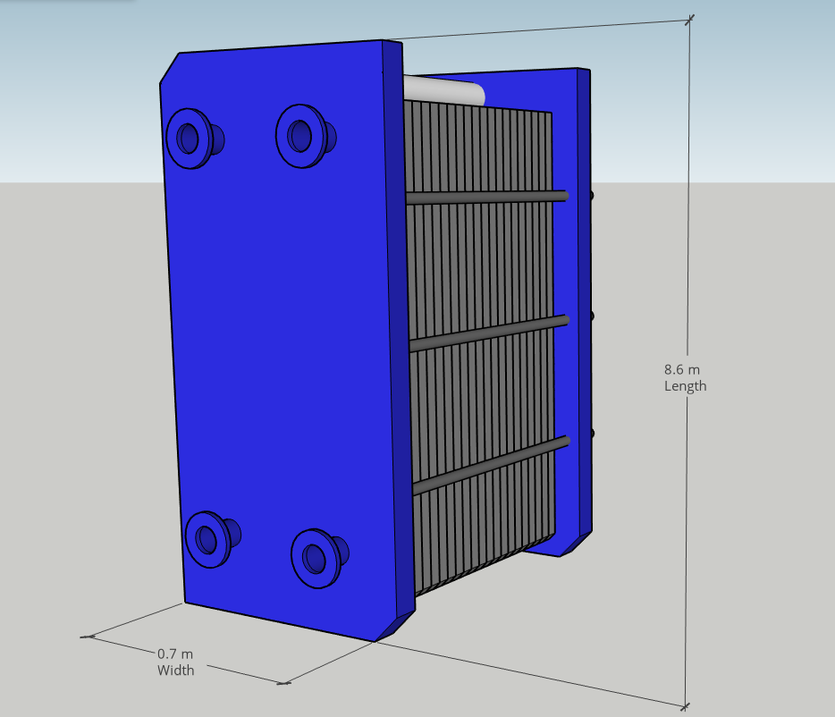

Figure 3.9: Heat Exchanger

1. **CONTAINER DESIGN**

As a final step of our design, we need to choose a container that will provide enough insulation and keep the beverage cold enough. In the endustry, containers are generally produced from Al cans or glass bottles. In this part, containers are analyzed for Al cans and glass bottles with calculations. There are many factors for selecting the best suitable material.

For the glass bottles, there are some disadvantages. One of it being an expensive material. In the terms of cost, glass bottles are not very good if we are thinking about low cost as a priority. In addition to this, for the consumer and the producer, it is not a very useful option because this material is brittle, heavy and that makes the transportation costs more.

However, it has some other advantages. In the glass bottles, the beverage keeps its taste better comparing to the cans. Glass bottles has also more asthetics image comparing to the cans. And finally, and most importantly they can hold the beverage colder than other materials because they have lower thermal conductivity.

For the cans, there are many advantages. In terms of cost, cans are more suitable because they are relatively cheaper than the others. They are also lighter than glass containers. Finally, cans prevent light damage. It is a very important point in terms of oxidation damage.

Now, we will make some calculations to decide which contaner to use.

Glass bottles:

* for 12 OZ =355 ml

Dimensions:

-Height= 228.6 mm=0.2286

-Body diameter=60.63 mm to the first layer r1=60.23 mm

Glass thickness=0.40 mm

kglass=0.8 (W/m.K)

r1=60.23 mm

r2=60.63 mm

T0=36.4 °C (temperature of human body)

Ti=5 °C (assumption of temperature of liquid)

Rtotal= ==5.76053*10-3

===5450.88 W

* For 16 OZ =500 ml

Dimensions:

-Height= 257.25 mm=0.25725 m

-Body diameter=64.69 mm to the first layer r1=64.29 mm

Glass thickness=0.40 mm

kglass=0.8 (W/m.K)

r1=64.29 mm

r2=64.69 mm

T0=36.4 C (temperature of human body)

Ti=5 C (assumption of temperature of liquid)

Rtotal= ==4.796713372*10-3

==6546.1489 W

Aluminium Cans:

* For 330 ml

Height=115.2 mm=0.1152 m

r1=66 mm

r2=66.30 mm

Can thickness=0.30 mm

kal=177 (W/m.K) for Aluminum Alloy 2024-T6 (4.5% Cu,1.5% Mg, 0.6% Mn)

T0=36.4 C (temperature of human body)

Ti=5 C (assumption of temperature of liquid)

Rtotal= =3.539863672*10-5

==887039.8102 W

* For 500 ml

Height=168 mm=0.168 m

r1=65.90 mm

r2=66.2 mm

Can thickness=0.30 mm

kal=177 (W/m.K) for Aluminum Alloy 2024-T6 (4.5% Cu,1.5% Mg, 0.6% Mn)

T0=36.4 C (temperature of human body)

Ti=5 C (assumption of temperature of liquid)

Rtotal= =2.4310x10-5

==1456184.819 W

According to these calculations, cans has higher heat transfer rate. Therefore, it means that they can get colder faster which a good point however it also means that they get warmer easily which is a downsize.

On the contrary, glass bottles have lower heat transfer rate and it is more likely to hold the liquid colder for a longer time. However it is bad when we want to cool down the beverage faster.

According to calculations above, we decide to use alimuninum cans because they have advantages of having lower cost, easier transportation and faster cooling. In terms of getting warmer when they are held in hands, we can state that although glass containers would get less warm, cans are still good options.

1. **RESULTS**

In the part above we did our calculations, research and then designed the elements that we need for our malt drink factory. In this part we will give our results in a tabular form for each design element.

Table 4.1: Oven Specifications

|  |  |
| --- | --- |
| Design Specifications for Oven |  |
| Size | 100 x 100 x 200 cm3 |
| Tambient | 30°C |
| Tsurface | 180°C |
| Tfilm | 110°C |
| Lc | 100 cm |
| Heat Transfer Surface | 2 x (100 x 100 cm2) |
| Nu | 5.47 |
| h | 0.173 W/m2C |
| Total Heat Loss | 1198 W |
| Drying Time | 21.63 minutes |

Table 4.2: In-line Water Heater Specifications

|  |  |
| --- | --- |
| Design Specifications for In-line Water Heater |  |
| $$T_{inlet}$$ | 20°C |
| $$T_{exit}$$ | 65°C |
| $$T_{surface}$$ | 120°C |
| $D$ iameter | 0.25 m |
| $L$ enght | 2 m |
| Pr | 7 |
| $$\dot{m}$$ | 0.5461 kg/m |
| $$Re$$ | 3.1966 x 103 |
|  | 24.3412 |

Table 4.3: Insulated Barrel Specifications

|  |  |
| --- | --- |
| Design Specifications for Insulated Barrel |  |
| Thickness of Metal | 1.5 mm |
| Inner Tank Radius (r0) | 11.4775 cm |
| Height (H) | 22.955 cm |
| Thickness of Insulation | 0.12 cm |

Table 4.4: Heat Exchanger Specifications

|  |  |
| --- | --- |
| Design Specifications for Heat Exchanger |  |
| Number of Plates | 100 |
| Plate Length x Width x Thickness | 8 m x 0.5 m x 0.002 m |
| Hot and Cold Water Gap | 0.008 m |
| Hot Water Temperature | 373.15 Kelvin/ 100°C |
| Cold Water Temperature | 273.15 Kelvin/0°C |
| Hot Water Mass Flow Rate | 0.0167 kg/s |
| Cold Water Mass Flow Rate | 4*0.0167 kg/s |
| Heat Exchanging Area | 400 m2 |
| Hydraulic Diameter | 0.0157 m |
| Reynolds Number | 1.3144 |
| Overall Heat Transfer Coefficient | 0.6833 W/m2K |
| Total Heat Transfer Resistance | 1.4634 m2K/W |
| Final Temperature of The Product | 20.49°C |

1. **COST ANALYSIS**

Cost analysis of the materials and equipment used in this section will be made. This analysis has been made based on the market of Turkey.

1. **Barley Grain**

Barley Grain is sold in various weight in Turkey. Here, barley with a weight of 20 TL is selected.

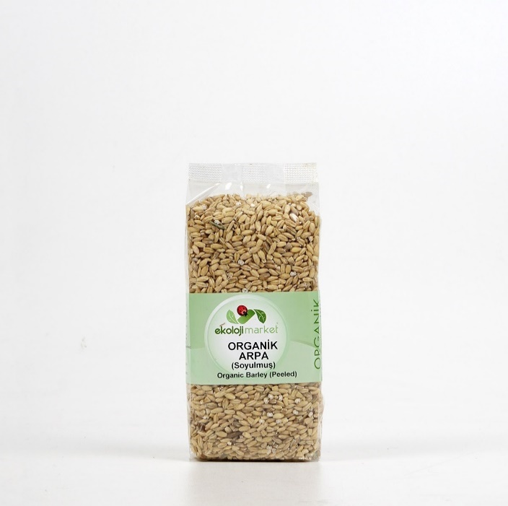Total Cost = 7.5kg * 2 * 20 TL = 300 TL

Figure 5.1 : Organic Barley

1. **Grain Drying Machine**

Local and foreign companies were investigated for the dryer closest to our designed dimensions. We found an offer from Kinkai and we decided this is the most suitable one for our project.

Total Cost = $3,000 * 6.86 + $100 * 6.86 = 21,266 TL

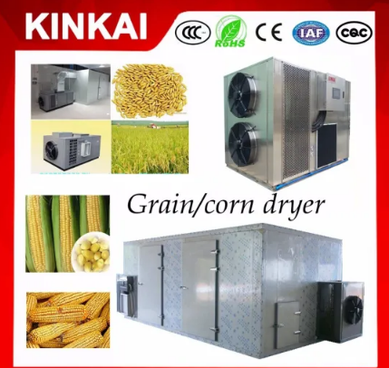

Figure 5.2:Grain Drying Machine

1. **Inline Water Heater**

In Task2, we designed in-line water heater. We supply hot water for the barrel with it. We simplified the heater like a circular tube and we made our calculations based on this. We choose Pentair brand from market because it was one of the best ones according to our price/quality criteria. Also it suitable for saltwater or fresh water, silent, robust and durable. Titanium and stainless steel materials are available but we take the stainless steel because it is more economic.

Total Cost : $649.99 * 6.86 + $350 * 6.86 = 6,860 TL

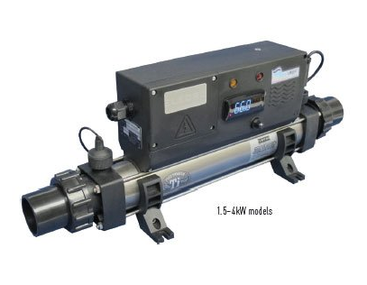

Figure 5.3 : In-line water heater

1. **Insulated Barrel**

We designed the insulated barrel to keep the grains at 65°C for 1 hour. We use stainless steel as a material of barrel because it is the most common one in insulated barrel industry and also it prevents corision and other chemical reactions.

Total Cost = $15.00 * 6.86 + $5.00 * 6.86 = 206 TL

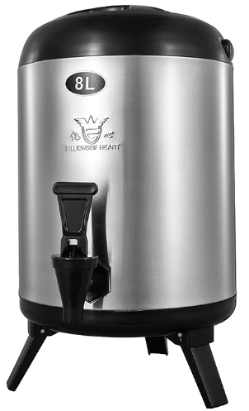

Figure 5.4 : Stainless Steel Insulated Barrel

1. **Plate Heat Exchanger**

There are many heat exchangers according to the usage types. In the calculations we made, we found that the most suitable design was the heat exchanger containing 100 plates.

Total cost = £699.99 * 8.55 + £100 * 8.55 = 6,840 TL

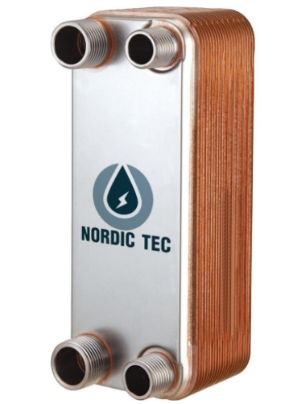

Figure 5.5

1. **Container**

In container design we consider two different containers such as glass or cans and finally we deciced to move with cans. We have 20 Liters of liquid and we need 61 cans. 70 cans should be ordered to avoid any hitches.

Total cost = 70* $0.05 * 6.86 = 24 TL

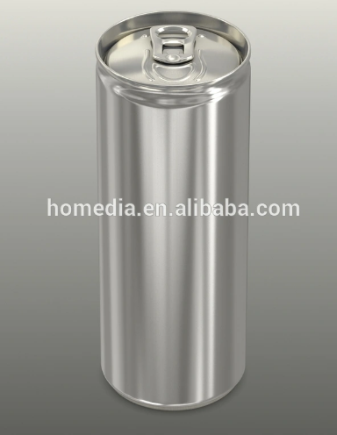

Figure 5.6 : 330ml can

1. **CONCLUSION**

The purpose of this project was to design a malt drink factory that had an oven, a water heater, an insulated barrel and a heat exchanger. First of all, we made researches about each element and learnt how they work, the materials that are widely used etc. Then, to be able to design those elements, we applied our knowledge on Heat Transfer course such as convection, radiation, conduction heat transfer, internal forced convection and heat exchangers; and we practiced real life problems and designs. We did our calculations mostly based on our textbook and its equations also did some iterations on MATLAB when needed. After designing those elements, we chose a container for keeping the finished products, which again heat transfer concepts applied. Finally, we did a basic cost analysis to see how much it would cost in real life.

Overall, we can conclude that we practiced almost every concept that we have learnt so far in this course.

1. **REFERENCES**

Cengel, Y. A. Heat Transfer: A Practical Approach (2007)

Encyclopedia Britannica, Inc 2012

<http://www.homebrewing.com/calculators/?page=tools&section=water&action=calculate>

<https://www.engineersedge.com/physics/water__density_viscosity_specific_weight_13146.htm>

<https://commons.wikimedia.org/wiki/File:Plate_frame_1.svg#/media/File:Plate_frame_1.svg>

<https://www.engineeringtoolbox.com/thermal-conductivity-metals-d_858.html>

<https://www.lv-soft.de/modulehelp/en/coil/index.html#!WordDocuments/typicalfoulingresistances.htm>

<https://kinkai.en.made-in-china.com/product/doZxLQqMEsaD/China-New-Advanced-Grain-Drying-Machine-Corn-Dryer-Oven.html>

<https://www.ekolojimarket.com/arpa-soyulmus-500-gr?gclid=Cj0KCQjw6PD3BRDPARIsAN8pHuGasOfzYr6IdLlXkWsHuw6UEHlUcJZW92VcvnNH5SrT_KHc7KAG2OgaAgm6EALw_wcB>

<https://kinkai.en.made-in-china.com/product/doZxLQqMEsaD/China-New-Advanced-Grain-Drying-Machine-Corn-Dryer-Oven.html>

<https://pentairaes.com/aqua-logic-in-line-heaters.html>

<https://www.alibaba.com/product-detail/8-liters-10-liters-12-liters_62152985224.html?spm=a2700.7724857.normalList.79.5bd724d1cfVrIn>

<https://www.amazon.co.uk/Nordic-Tec-Ba-60-100-Stainless-Exchanger/dp/B07FDFLLLZ/ref=sr_1_83?crid=2M9PIQQX8HSLJ&dchild=1&keywords=plate+heat+exchanger&qid=1593623991&s=diy&sprefix=plate+heat+ex%2Cdiy%2C188&sr=1-83>

<https://interpackgroup.en.made-in-china.com/productimage/KjMnvfplrSVB-2f1j00jIOfPLzEVQqr/China-330ml-Empty-Aluminum-Sleek-Can-for-Carbonated-Drink-Beer-Soda-Price-for-Aluminum-Can-Food-Grade.html>

<http://www.kurutma.net/index.html>

<https://www.dummies.com/food-drink/drinks/beer/buying-beer-choosing-a-container/>

<https://www.ball.com/eu/solutions/markets-capabilities/capabilities/beverage-cans/standard-range>

<https://gpi-tanks.com/>

1. **APPENDIX**

**In-line Water Heater MATLAB Iteration Code:**

Ti=20; %C

Te=65; %C

Ts=120; %C

Cp=4.1818*10^3; %J/kg·C

k=598.4*10^-3; %W/m·C

mu=0.001002; % N*s/m^2

mu_s=0.2822*10^-3; % N*s/m^2

D=0.25; %m

L=2; %m

Pr=7; % Cp*mu/k

m_guess=input('Mdot Guess :') %kg/s

for iter_count=1:1:1000

Re=(4*m_guess)/(pi*D*mu);

if Re<2300

Nu=1.86*((Re*Pr*D/L)^(1/3))*(mu/mu_s)^0.14;

h=(Nu*k)/D;

else

f=(0.79*log(Re)-1.64)^-2;

Nu=((f/8)*(Re-1000)*Pr)/(1+12.7*(f/8)^0.5*((Pr^(2/3))-1));

h=(Nu*k)/D;

end

m_calc=(h*pi*D*L)/(Cp*log(Ts-Te)/(Ts-Ti))

if round(m_calc,4)==round(m_guess,4)

break

else

m_guess=m_calc;

end

end

if Re<2300

disp ('Laminar Re<2300')

else

disp('Turbulant Re>2300')

end

disp(Re)

disp('mdot calculated')

disp(m_calc)

disp('Number Of Iterations')

disp(iter_count)

**Heat Exchanger MATLAB Code:**

%%TRADITIONAL PLATE EXCHANGER CALCULATION%%%

Number_of_plates=100; %[-]

Plate_Length=8.000;%[m]

Plate_Width=0.500;%[m]

Plate_Thickness=0.002;%[m]

Hot_and_Cold_gap=0.008; %[m]

Hot_water_temperature=373.15; %[K]

Cold_water_temperature=273.15;%[K]

Hotfluid_mass_flow=0.0167;%[kg/s]

Coldfluid_mass_flow=Hotfluid_mass_flow*4;%[kg/s]

Hot_and_Cold_fouling_resistance=0.00005; %[m2K/W]

Plate_metal_conductivity=50;%[W/mK],

Cp_fluid=4180; %[J/kgK]

A_hx = Plate_Length * Plate_Width * Number_of_plates; %Heat exchanging Area [m2]

N_ch = Plate_metal_conductivity ;%Nr of hot and cold channels [-]

A_fch = Hot_and_Cold_gap * 0.5; %A_flow/channel [m2]

C_fch = 2 * (Hot_and_Cold_gap + Plate_Width); %Channel Circumference [m]

D_hyd = 4 * A_fch / C_fch; %Hydraulic Diameter [m]

A_flow = N_ch * A_fch; %Flow Area per fluid [m2]

G = Hotfluid_mass_flow / A_flow; %Fluid Mass Velocity [kg/m2/s]

u_w = 0.0010005; %Water viscosity @ 20 deg.C [Pa.s]

k_w = 0.3455; %Water conductivity @ 20 deg C [W/mK]

Re = G * D_hyd / u_w; %Reynolds [-]

Pr = 6.99; %Prandtl water @ 20 deg C[-]

U_w = 0.023 * k_w/D_hyd * Re^0.8 * Pr^0.4; %Hot & Cold heat transfer coefficient[W/m2/K]

R_pl = Plate_Thickness/Plate_metal_conductivity; %Plate resistance / m2 [m2W/K]

%Total heat transfer resistance / m2

R_t = 2/U_w + 2 * Hot_and_Cold_fouling_resistance + R_pl; %[m2W/K]

U_oa = 1 / R_t; %Overall Heat transfer Coefficient [W/m2/K]

ITD=Hot_water_temperature-Cold_water_temperature;

delta_T_fluid = ITD * U_oa*A_hx / (U_oa*A_hx + Hotfluid_mass_flow*Cp_fluid);

Q_fluid = Hotfluid_mass_flow * Cp_fluid * delta_T_fluid; % [W]

Temperature_of_hotwaterfinal=Hot_water_temperature-(delta_T_fluid+273)

Temperature_of_coldwaterfinal=((delta_T_fluid)+273-Cold_water_temperature)/4

**Thickness of Insulation MATLAB code:**

%optimization of H and r0

format short

syms r h

eq1=2*pi*(r^2)+19000*(r^-1);

eq2=r>=0;

eq3= 0 ==diff(eq1,r);

R=solve(eq3,eq2,r);

r=R

H=9500/(pi*r^2);

h=H

%iteration for insulation thickness

T_inf=21; %[C]

T_tank=65; %[C]

T_final=63;%[C]

k_steel=15.1%[W/m.K]

k_ins=0.026 %[W/m.K]

d_steel=8055 %[kg/m^3]

d_grain= 650 %[kg/m^3]

H=22.955 %cm

r1=11.5 %cm

Cp=4.19 %[kj/kg.K]

h_b=10 %W/m^2

h_s=40 %W/m^2

h_t=10 %W/m^2

Abot=pi*r1^2

Atop=Abot

Aside=2*pi*r1*H

deltax_steel=0.15 %cm

r2=r1+deltax_steel %cm

deltax_ins=input(' bir sayı girin (cm) :')

r3=r2+deltax_ins; %cm

i=0

while i<5000

i=i+1;

Rbot=deltax_steel/(k_steel*Abot)+deltax_ins/(k_ins*Abot)+1/(h_b*Abot);

Rside=log(r2/r3)/(2*pi*k_steel*H)+log(r3/r1)/(2*pi*k_ins*H)+1/(h_s*Aside);

Rtop =deltax_steel/(k_steel*Atop)+deltax_ins/(k_ins*Atop)+1/(h_t*Atop);

Rtotal= (Rbot*Rside*Rtop)/(Rside*Rtop + Rside*Rbot + Rbot*Rtop);

Qdot=(T_tank-T_inf)/Rtotal ;

deltaT= Qdot/(-d_grain*(pi*r1^2*H)*Cp) ;

total_heat_change=deltaT*3600

if total_heat_change>-2

deltax_ins=deltax_ins-0.0005

else

break

end

end